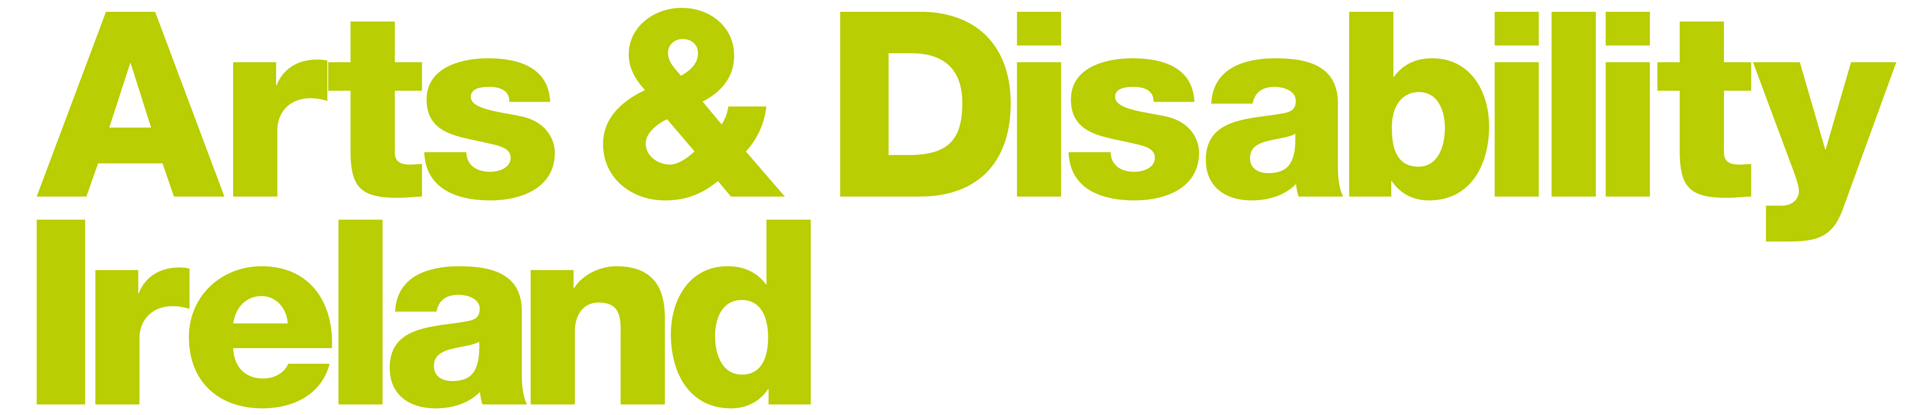

Finance & Governance
Role Spec

The Organisation:
Arts & Disability Ireland (ADI) is the national development and resource organisation for arts and disability.
We promote engagement with the arts at all levels – as professional artists, audience members and arts workers – for people of all ages with disabilities of all kinds.
We work towards arts programmes and arts venues becoming fully accessible experiences for all audiences.
We advocate for inclusive policy and practice which provides real access to all aspects of the arts for people with disabilities, and for everyone.
The Role:
Arts & Disability Ireland are seeking an individual with previous board-level experience with proven knowledge in financial management or accountancy and/or governance. Ideally the candidate will be a qualified Accountant, ACA or CIMA qualified, with senior management experience.
Responsibilities will include the following:
- To have a deep insight into all Financial and Governance policies, procedures, controls and propose any recommendations for change.
- To have oversight of compliance and risk management in the organisation.
- Have an overview of the finances to advise the Board on financial implications of proposals, cash flow problems etc.
- Oversight of compliance and risk management in line with usual board responsibilities
- To have an understanding of good governance and experience of implementing good governance practice in the private, non-profit or public sector
- To be an authorised signatory of the Charity/Non Profit.
The ADI Board are currently in the process of setting up a Finance subcommittee. Once in place, this Directors role will be to evaluate and monitor the adequacy of Financial controls and procedures and ensure the organisation is compliant with best practice principles.
Board Meetings:
There will be 4 board meetings and 1 AGM. Meetings are held in Dublin city centre.

