The New Theatre Quicksand Synopsis for the Relaxed
Performance Audience.

Welcome to the The New Theatre! Located at:
43 Essex Street East
Temple Bar
Dublin 2
D02 XH96

Getting Here
The New Theatre, located on East Essex Street in Temple Bar is served by the following transport options:
By Bus: 25, 25a, 25b, 25d, 26, 66, 66a, 66b, 67, 123, 150, 151, 27, 49, 54a, 56a, 77
By Luas: Red Line, Jervis.
By Car: Parking available at Fleet Street Car Park, Christ Church Car Park and free on-street parking after 7pm on Ormond Quay.

Temple Bar can be very busy at the weekend with tourists. A quieter approach is from Parliament Street.

This is the entrance to the theatre. The box office to collect your ticket and door to the auditorium is at the back of Connolly bookshop.

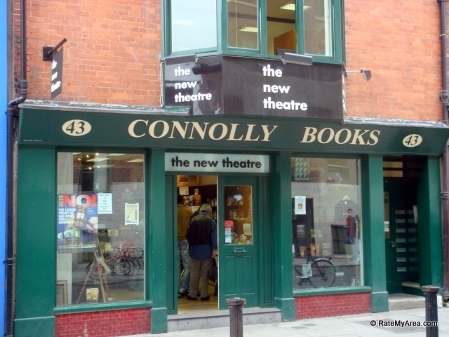

This is the inside seating area of the theatre. Several aisle seats will be reserved near the stairs for audience members who think they might need to move in and out of the theatre during the performance. 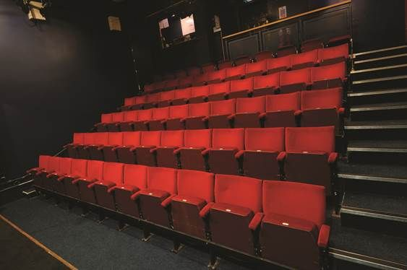

The Play.

In Quicksand there are two characters in the cast Joy, the mother and Joe, her son. The play starts with Joe in a police interview room. Joy is trying to find out what he is charged with. Joe is charged with a computer hacking crime.

In the subsequent scenes Joe is on parole licence, under curfew living back in his mothers house. We see dialogue scenes of their domestic life together. We also see Joe and Joy do monologues to the audience about their private romantic lives that they keep secret from each other. Joy is very worried about the upcoming trial.

Life gets more complicated for Joe as the play progresses. A girl he has met called Petra goes missing. The police are suspicious that Joe is involved in her disappearance. Newspaper reporters wait outside his house. The police question him. Joe decides to leave Joys house. In the final scene of the play Joe tells Joy what happened the night Petra went missing.

There are no loud or sudden noises in the soundscape. There are sound and light changes between scenes. As the story becomes more tense and Joe feels under threat the soundscape builds tension and becomes less melodic. There are strip lights on both sidewalls of the stage that pop off and on suddenly a couple of times during the play.

Front of House Information.

The play lasts for 70 minutes. During that time low level lights will remain on in the audience seating area.

There will be an usher on the door into the auditorium to let you out and back in if you need to take a break during the performance.

Please let them open and close the door for you as they will ensure it does not bang and make a loud noise.

Patrons will be allowed back in at 15 minute intervals during the play, approximately 4 times during the length of the performance.

The front of house area has a long table with bench seats where you can sit.

There is one unisex toilet. It is on the left handside just inside the main door into the auditorium.

If you have any queries or concerns our front of house staff are happy to chat to you on the day. Or telephone us in advance on Tel: +353 (0)1 670 3361or E-Mail: info@thenewtheatre.com

Enjoy the performance and we hope to see you back again soon at The New Theatre

Pamela McQueen
Creative Producer.

