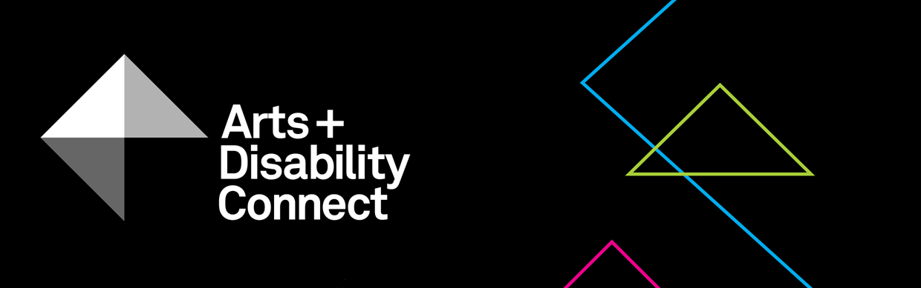

About the Arts and Disability Connect (ADC) scheme 2019

What is ADC?
The Arts and Disability Connect (ADC) is a funding scheme available to individual artists with disabilities.
The Arts and Disability Connect (ADC) scheme is designed to support artists with disabilities to make new ambitious work. It offers artists an opportunity to connect with other artists or venues or to engage in mentoring and training; to make a change in their practice; to ‘step up’ in terms of scope and scale; to engage in new learning experiences and working relationships; and to reach new audiences.
This scheme is funded by the Arts Council/An Chomhairle Ealaíon and managed by Arts & Disability Ireland (ADI).
ADC has been created in line with Arts Council commitments outlined in “Arts and Disability Policy (2012 – 2016)” and is intended to respond to changing needs within this sector.
All Arts Council awards are informed by the Council’s ten-year strategy (2016–2025). Making Great Art Work: Leading the Development of the Arts in Ireland

What are the aims and objectives of ADC?
By prioritising links and connections, the ADC scheme aims to support established and emerging artists with disabilities to develop their practice and make new work while connecting with the wider arts sector in Ireland.

What funding is available?
There are three different strands within ADC, each with specific aims, objectives and criteria against which applications will be assessed. These are:
Arts and Disability Connect New Work
Maximum award €8,000. For established artists with a strong track
record in their professional practice who wish to work with other artists and arts partners, to develop ambitious new work and plan its production and presentation in established arts organisations, venues, and festivals etc.
Arts and Disability Connect Mentoring
Maximum award €2,000. For artists at all stages of career development, including emerging artists, who wish to engage in mentoring opportunities.
Arts and Disability Connect Training
Maximum award €1,000. For artists at all stages of career development, including emerging artists, who wish to engage in professional development and other learning opportunities within the island of Ireland.
A total fund of €29,000 is available for distribution across the three awards in 2019.
Please note: applicants may submit an application for only one strand of ADC i.e. you must choose to apply either for Arts and Disability Connect New Work or Arts and Disability Connect Mentoring or Arts and Disability Connect Training.

Am I eligible to apply for ADC?
To be eligible you must be an individual artist with a disability, who can demonstrate a professional practice in your artform and who is living in the Republic of Ireland.
The Arts Council and Arts & Disability Ireland take their definition of disability from the UN Convention on the Rights of Persons with Disability which states:
‘Persons with disabilities include those who have long-term physical, mental, intellectual or sensory impairments which, in interaction with various barriers, may hinder their full and effective participation in society on an equal basis with others.’

If you are an artist with a disability who needs funding to pursue your artwork on a professional level, you should consider applying to the ADC scheme. If you are a person with a disability who would like to explore the arts for the first time, ADC may not be the best starting point for your arts journey.

Who is not eligible to apply?
People who are not eligible to apply include those who:
- do not have a disability as outlined above
- are not living in the Republic of Ireland
- are already in receipt of Arts Council funding for the activities for which they are applying
- have submitted an application for more than one strand of ADC
- are in undergraduate education during September 2019 - August 2020

Please read the following before submitting your application: About the Arts and Disability Connect scheme, Application Forms and Guidelines. These will be available to download from Monday 18 February at: www.adiarts.ie/connect

How do I apply?
You can download the application forms, guidelines and information at: www.adiarts.ie/connect. You must submit your completed form along with all supporting material to amie@adiarts using WeTransfer by
4pm on Monday 8 April, 2019.
Can ADI give me advice on making a good application?
Yes, Arts and Disability Ireland can provide up to one hour’s support to artists before they submit their application to Arts and Disability Connect. Once the application forms and guidelines are published on the 18th February you can book in this support up until the 5th of April. To book application support email amie@adiarts.ie or phone 01 8509002.
Can I apply using alternative formats?
Yes alternative format applications will be accepted. These may include audio recordings (.mp3) to facilitate applicants with dyslexia or video recordings (.mp4) to facilitate applicants who are ISL users. In order to submit alternative format applications please contact ADI before Monday 1 April.
How does the decision making process work?
Applications that do not meet the published criteria will be ineligible.
All applications meeting the published criteria will be assessed by an independent panel, which will include practising artists and arts professionals. The panel will be chaired by an Arts Council member and facilitated by ADI in a non-voting capacity.
Please note that a shortlisting process may apply depending on the amount of applications received.
How do panel members declare a conflict of interest?
In order to ensure fairness and equity in decision-making, panel members are required to declare an interest where they have a close personal or professional link with the applicant or are linked in any way with the application. An ‘interest’ is either ‘pecuniary’ or ‘non-pecuniary’ (e.g. familial relationships, personal partnerships, or formal or informal business partnerships, etc.).
The interest must be declared as soon as the panellist becomes aware of it. This may be at the point when s/he is approached to sit on the panel (if the ‘interest’ is known at that stage) or following receipt of the list of applicants.
Where an interest is declared, the panellist will not receive papers relating to that applicant and will be required to leave the room when the specific application is being reviewed. Where this situation arises, the chair will vote in lieu of the panellist.
In some instances a panellist may not realise that a conflict of interest exists until s/he receives and reviews the panel papers. In such instances the panellist must alert an ADI staff member or the panel chair as soon as they become aware that a conflict may exist.
What is the scoring process at the panel meeting?
The panel is asked to score applications with the following system:
A – Must Fund (10 points): this means that, in the view of the panel member, the application is deemed to have fully met the criteria for the award and merits funding on that basis, to the amount requested where possible.
B – Should Fund (8 points): this means that, in the view of the panel member, the application is deemed to have met the criteria to an extent sufficient to merit funding should resources allow.
C – Could Fund (5 points): this means that, in the view of the panel member, the application is deemed to have met the criteria, but to a lesser extent within the competitive context than other applications.
D – Not a Priority (2 points): this means that, in the view of the panel member, the application is deemed to have not met the criteria to an extent sufficient to merit funding.

How will my personal data be treated?
Privacy and data protection rights are important to Arts & Disability Ireland and we are committed to safeguarding the privacy rights of all our applicants. ADI is committed to protecting the privacy of individuals in relation to the processing of personal data that we may collect, access, use and/or disclose. Any personal information that is volunteered to, or sought by ADI will be treated with the highest standards of security and confidentiality, in accordance with data protection law and regulation and at all times. To read ADI’s Data Protection and Privacy Policy please click here.
When will I get a decision?
You will receive a decision by June 2019.

If I am unsuccessful, can I get feedback on my application?
Yes. Feedback will be available on request from ADI.

What is the appeals process?
Applicants may appeal against a funding decision on the basis of an alleged infringement or unfair application of, or a deviation from published procedures. If you wish to appeal a funding decision, please contact the Head of Arts Participation at the Arts Council. http://www.artscouncil.ie/Contact-us/Staff-and-adviser-lists/

Are application forms and guidelines available in Irish?
Arts and Disability Connect guidelines and application forms can be made available in the Irish language upon request.
Tá leaganacha Gaeilge de na foirmeacha iarratais agus treoirlínte ar fáil ach iad a iarraidh.

