Half Light
devised and written by
Bombinate Theatre and the ensemble

Programme notes for Audio Described Performance
Cork Midsummer Festival 2018
The Granary, Cork on Sunday 17th June at 2pm
Touch tour at 1pm

Welcome to the introductory notes for Half Light, devised and written by Bombinate Theatre and the ensemble. The play is directed by Mollie Molumby. The Costume and Set design is by Ursula McGinn and the Lighting Design is by Dara Hoban.
The show lasts for just under an hour, without interval.

ABOUT THE SHOW
Imagine that you’re walking up a mountain, through a forest of pine trees, and you’re trying to find your Dad. He’s been taken by a monster…
Meet Robin, a ten-year-old boy travelling through the magical woodland of his father’s storybook. A tale which is as true as it is untrue. Half dark and half light.

ABOUT THE SET
A row of artificial Christmas trees lines the back of the space, curving slightly to create a little clearing where the performance takes place. The trees are not decorated, but lots of little things have been placed under them like presents. These are things you might expect to find in a garden shed, or hidden up in the attic. There are baskets and birdcages, a spade and watering can, boxes, buckets and a small step ladder standing on a threadbare rug.
Here and there, logs and tree stumps sit, with colourful bits and bobs piled on top. An anorak has been left hanging on the ladder, and a cuckoo clock sit on one of the rungs.
Over on the right hand side is a coat stand with various things hanging on the hooks, like a feather shawl, an apron and some woolly jumpers and scarves. A cymbal on a tall stand is just next to it. Beside this is a keyboard and stool. A big basket sits on the floor by the keyboard with three balloons tied to it – one red, one blue and one yellow. They float and sway gently.
Here, by the piano, is the musicians’ area. There are little bookshelves on the floor, crammed with old leather-bound books, and fruit crates and boxes. Little musical instruments sit on top of each box, like cowbells, a little rainbow xylophone, a small accordion. There is a slide whistle, a wood block and a wonderful wooden gadget for making sound effects like locking doors. A flute sits upright on its stand, with a melodica and tambourine on a nearby crate.
The lighting in this show gets darker as the story unfolds. At the beginning the stage and audience are brightly lit. Then little by little the lights go down in the theatre and focus more on the characters and their actions. As the story begins on a cold evening, the lights are tinged with blue, as a fine mist creeps across the stage.

ABOUT THE CHARACTERS & COSTUMES
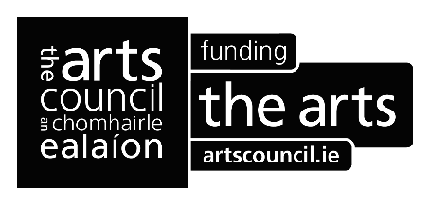
Robin, a ten-year-old boy, is played by Fionn Foley, who is not ten! In fact, all of the actors are in their twenties, but play characters at lots of different ages. Robin has curly dark blonde hair and his big eyes get wider and wider as he gets carried away by his story. He wears a wine woolly jumper and check pyjama bottoms with green wellies. On his head is a patterned woolly hat with plaited strings hanging from the ear-flaps and a bobble on top.
Sally is played by Martha Grant. She sits in the chair nearest the centre and plays the flute and melodica, as well as a whole host of other instruments.
She has long blonde hair pinned back behind her ears and falling down her back. She wears a red shirt with a navy waistcoat embroidered with flowers and a long cream, cotton skirt with lace trimming at the bottom. Sally also wears neat lace-up boots.
Guitar Man is played by Richard Durning. He is a tall man with shaggy dark brown hair and a bushy beard. He wears a white cotton shirt, brown trousers with braces to hold them up, and brown leather shoes. He plays… the guitar! Sometimes he picks up a pair of drumsticks with white fluffy bobbles on top to play the cymbal.
Lastly, we meet Karen, played by Juliette Crosbie. Karen has tied her light brown hair back in a plait and pinned it to her head with a red rose. She has long, dark eyelashes and red lipstick. Karen wears a white ruffled blouse and short black trousers that come to the knee. She wears mustard-coloured tights and black shoes with straps on. Karen plays the piano mostly, and some of the bells and wood blocks.
Karen, Sally and Guitar Man play all the music in the show and help Robin tell us his story. Sometimes they play different characters in that story, like an innkeeper, or a mysterious crow. They pick up costumes from the coat rack or the baskets to help them turn into these different people as we go on our adventure.
*****
That concludes the introductory notes for Half Light. They were prepared by Bríd Ní Ghruagáin, who will describe performances along with Máirín Harte and Anne Hornsby. Audio description for Bombinate Theatre is provided by Arts and Disability Ireland with support from The Arts Council.
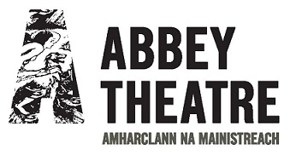
Thank you. Go raibh maith agaibh.

