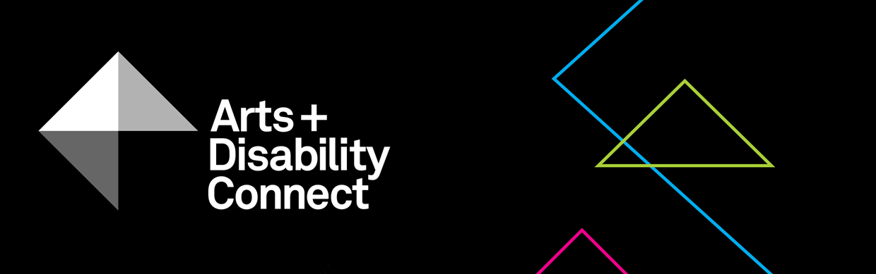

Arts and Disability Connect Training
Guidelines Round Two 2020

About the Arts and Disability Connect scheme
ADC is a funding scheme available to individual artists with disabilities.
There are three different strands within ADC, each with specific aims, objectives and criteria against which applications will be assessed. The three strands are: Arts and Disability Connect New Work, Arts and Disability Connect Mentoring and Arts and Disability Connect Training.
This scheme is funded by the Arts Council/An Chomhairle Ealaíon and managed by Arts & Disability Ireland (ADI).
Please read the following documents before submitting your application: About the Arts and Disability Connect scheme, Training Application Form and Training Guidelines. These will be available to download from Monday 07 September 2020 at: www.adiarts.ie/connect
Deadline for all ADC applications: 4pm, Monday 19 October 2020.

Arts and Disability Connect Training Guidelines

- Aims and objectives
Arts and Disability Connect Training aims to support artists across all artforms and at all stages of career development, including emerging artists, to engage in training courses, events and other professional development opportunities delivered by established artists and professional arts organisations in Ireland. The proposed training may be limited to a concentrated period of time such as a weekend or a week, or it may include attendance at a number of events spread out over a maximum of twelve months. Artists wishing to avail of professional development opportunities outside the island of Ireland should not apply to this award and should contact the Arts Council about Travel and Training opportunities.
In this way, Arts and Disability Connect Training aims to add value to other existing supports for professional development and assist artists to:
- learn new skills and extend current practice through participation in:
  - training days, short courses, masterclasses in the applicant’s own artform
  - other professional development opportunities such as residencies etc.
- develop new strategic contacts with other artists and arts organisations within the island of Ireland

All applicants must contact Arts & Disability Ireland in advance of the application deadline in order to discuss their chosen training provider
OR get advice on appropriate training providers.

- Timeframe
All proposed training, events or programmes must be completed between January 2021 and the end of December 2021.

- Purpose
The funding can be used to pay for the applicant’s expenses related to the course or event fees, materials, access and travel within the island of Ireland.

- Restrictions
Artists who received funding through round one of ADC in 2020 cannot apply for round two.
Funding is not available for training that has already taken place or that will have commenced before January 2021.
Funding is not available for formal education courses at primary, secondary or third level, vocational education or recreational classes.
Artists cannot include artist’s fees towards buying time to take part in their proposed training plan.
While the award allows for the purchase of materials for use during the training period, it is not designed to be a capital grant and may not be used to cover the purchase of significant items of equipment.

- Maximum amount available
The maximum amount available is €1,000.
- Supported applications
The Arts and Disability Connect scheme is aware that some artists require additional supports to submit an application. Where this is necessary we welcome applications that are compiled by staff in supported studios, support workers, family or friends on behalf of an artist with a disability. In the application it is possible to have two voices, that of the applicant artist and the person who is supporting them to apply. However the priority for the decision making panel is to hear the voice and views of the individual artist who is applying.
- Criteria
All applications must be led by an individual artist with a disability.
As with all Arts Council awards, the ADC applications will be assessed against criteria of (i) artistic merit; (ii) how they meet the objectives of the award and (iii) feasibility.
- Artistic merit
You must demonstrate:
- a strong track record in emerging or established arts practice
- evidence of a professional arts practice
- evidence that the artists/ producers/ arts organisations delivering the training are skilled and experienced within their own professional arts practice

- Meeting the objectives of the award
You must describe:
- your professional development needs and the ways in which the proposed training will address these needs
- if you have received a Training award in the past and this proposal is similar please outline how this training proposal will further benefit your practice

- Feasibility
You must include:
- detailed information about the content of the proposed training/ events and the artists responsible for delivery of training
- a timetable for the proposed training/ event/s
- evidence that you have secured a place on the course
- information about your access requirements (if applicable) and how they will be met. You can find more detail on access requirements in our FAQ document
- a clear breakdown of the proposed expenditure
(and any other income that might be relevant to the proposal)

- Other conditions applying to all Arts Council awards:
All awards are offered subject to the availability of funds. Awards may be withheld or divided among applicants at the discretion of the Arts Council.
Successful applicants must acknowledge the support of the Arts Council and ADI in all promotional material associated with their work.
All correspondence should be with the applicant directly, unless otherwise agreed.
Successful applicants must report on the use of the award and supply receipts where appropriate.

- Covid-19 Related Public Health Guidance
In preparing your application, you should base it on the best public health advice and guidance available at the time you are making your application. Given this, you should ensure that what you are proposing is feasible or adaptable should social distancing and/or other public health measures impact on all or part of the award period.
- How to apply
Using one WeTransfer, you must submit:
- A completed application form
- A signed signature page
- Your CV and CV of the trainer/s (max 3-4 pages each)
- A letter confirming your place for the training
- Examples of previous work - max 10 images, 3 texts, 3 video work or 3 audio clips (max 5 mins each) and examples of any relevant press or media coverage (max 2 pages)
- List of files submitted
File types that you can submit as part of your application:
Text files - .doc or.docx
Image files - .jpg
Sound files - .mp3
Video files - .mp4
Adobe Acrobat Reader files - .pdf
The upload limit for one WeTransfer is 2gb in total. Only one WeTransfer can be submitted by each applicant, this must include a completed application form and all support materials. Please note: applicants may submit an application for only one strand of ADC.
As we cannot guarantee that decision panel members will have access to website links, please include files as part of your supporting materials where possible.
Please bear in mind the competitive context of the award when submitting support material. Select materials carefully and ask yourself if they make a persuasive case for your specific proposal.

- How to use WeTransfer
- Go to www.wetransfer.com
- Add your files: select all of the files you want to submit
- Email to: amie@adiarts.ie
- Your email: (insert your own email address)
- Message: Arts and Disability Connect Training application - (insert your name)
- Click Transfer
- WeTransfer will email you a verification code,
(enter this 6 digit code)
- Click Verify
- You will receive a confirmation email from WeTransfer stating that the files have been sent and a confirmation email when the files are downloaded by ADI

Including architecture, circus, dance, film, literature, music, opera, street arts and spectacle, theatre, traditional arts and visual arts.
Professional arts organisations might include artform resource organisations, festivals, production companies, venues, studios, etc.

