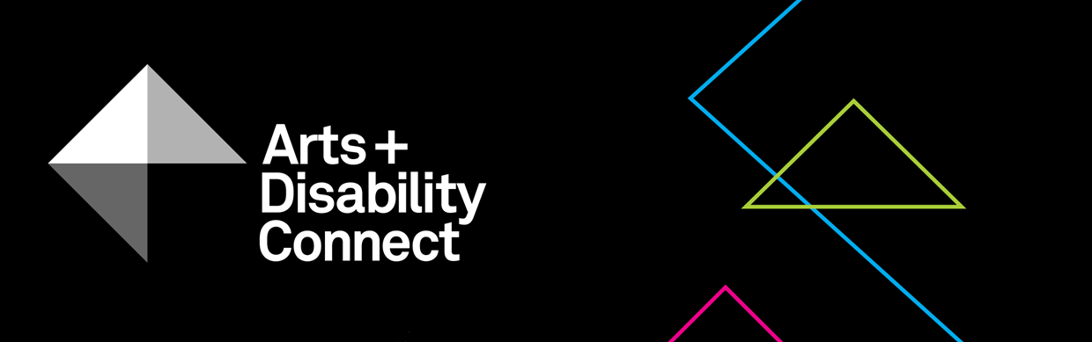

Arts and Disability Connect Training
Application Form 2019
Read the following before submitting your application:
About the Arts and Disability Connect scheme and Training Guidelines.

- Please complete this form using Arial 14pt
- All questions must be answered

Section One
- Artist Details:
Name:
Address:
Tel:
Email:
Website:
Artform:
Support Details:
Support email:
(Artists who are being supported to complete their application can include the email address of the person who is supporting them.
This support person will be copied into email correspondence.)
Access requirements:
Include details of your access requirements as they relate to this proposal (max 200 words).

- Declaration:
The Arts Council and ADI take their definition of disability from the UN Convention on the Rights of Persons with Disabilities, which states:
‘Persons with disabilities include those who have long-term physical, mental, intellectual or sensory impairments which, in interaction with various barriers, may hinder their full and effective participation in society on an equal basis with others.’
Using this definition, would you define yourself as being a person with a disability? You must tick one box, either Yes or No.

Yes No

3 Contact:
Have you contacted Arts & Disability Ireland for advice on appropriate training providers? You must tick one box, either Yes or No.
Yes No

Section Two

- Arts and Disability Connect Training Proposal:
- Amount requested: €___________
Make sure this matches the figure in your budget and that it does not exceed €1,000.
- The training plan:
Ensure that you have read the criteria on page 4 of the Training Guidelines document before completing this section (max 200 words)

Dates | Training/  Event/  Programme | Organisation | Artist/s who will deliver the training | Arts Council Funded (yes/no)

- How will this training proposal benefit your practice?
(max 200 words)

- Budget
This template budget breaks down your costs for your training. Please ensure:
- all costs are included
- the budget is balanced
i.e. that total income matches total expenses
- the amount requested is not higher than the maximum offered
- any relevant income is included and clearly marked ‘in-kind’ or ‘in cash’.
Item | Amount | Notes
1. Applicant | €
Fees
Materials
Travel/subsistence
Access
Other expenses
Total expenses
3. Amount sought from ADC Training
4. Other income if relevant (please list) |  | Indicate if in-kind/cash and if confirmed/unconfirmed
Total income

- Signatures:
I have read the award guidelines and conditions and agree to be bound by them. I certify that:
- the application is led by the applicant
- the information in this application is correct to the best of my knowledge
Signed: (Applicant)
Remember this page must be scanned or photographed and submitted as a .pdf or .jpg as per the guidelines.

- Final Checklist:
Please check you have answered all of the questions on the Arts and Disability Connect Training application form using Arial font, size 14pt. Please ensure that you have saved your completed application form as a .doc file.
Please check you have uploaded all of the required supporting material along with your completed application form:
- A .pdf or .jpg of the signed signature page

- Your CV (Maximum of 3-4 pages)

- Confirmation of your place on the training course/s listed

- Information/ brochures about the training course/s listed, the organisation offering it, and the artist/s delivering it
- Examples of previous work (max 10 images or 3 texts/ video work/ audio clips (5 min max) of up to 1gb in the following formats: .jpg; .wav; .mp3; .mp4; .pdf; .doc) and examples of any relevant press/ media coverage (2 pages maximum)

- List of supporting material provided in a word file (.doc)

- The upload limit for one WeTransfer is 2gb in total. Only one We Transfer can be submitted by each applicant, this must include a completed application form and all support materials.
- Please note: applicants may submit an application for only one strand of ADC i.e. you must choose to apply either for Arts and Disability Connect New Work or Arts and Disability Connect Mentoring or Arts and Disability Connect Training.

You must submit your completed application form along with all supporting material to amie@adiarts.ie using WeTransfer
by 4pm on Monday 8 April, 2019.
Feedback
Thank you for applying to Arts and Disability Connect Training.
The Arts Council and ADI would appreciate it if you could provide feedback on this scheme. Your comments will help to shape the scheme in the future.
We will send you a link to a survey on receipt of your application.

