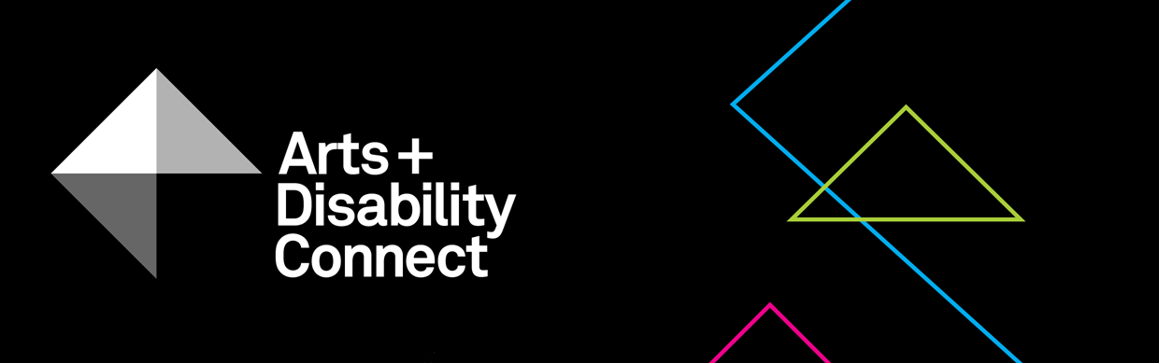

Arts and Disability Connect New Work Guidelines Round Two 2020

About the Arts and Disability Connect scheme
ADC is a funding scheme available to individual artists with disabilities.
There are three different strands within ADC, each with specific aims, objectives and criteria against which applications will be assessed. The three strands are: Arts and Disability Connect New Work, Arts and Disability Connect Mentoring and Arts and Disability Connect Training.
This scheme is funded by the Arts Council/An Chomhairle Ealaíon and managed by Arts & Disability Ireland (ADI).
Please read the following documents before submitting your application: About the Arts and Disability Connect scheme, New Work Application Form and New Work Guidelines. These will be available to download from Monday 07 September 2020 at: www.adiarts.ie/connect
Deadline for all ADC applications: 4pm, Monday 19 October 2020.

Arts and Disability Connect New Work Guidelines

- Aims and objectives
Arts and Disability Connect New Work aims to support established artists with disabilities working in all artforms to connect with other experienced artists, arts professionals, and arts organisations in the Republic of Ireland. This award is focused on the making and development of ambitious new work and the planning of its production and presentation.
By prioritising ‘connection’, Arts and Disability Connect New Work aims to support professional artists with disabilities to:
- extend their practice and make ambitious new work in collaboration with a strategic arts partner
- build relationships with key people or organisations experienced in the high-quality presentation and production of work
- participate in a public presentation of the finished work or work-in-progress (e.g. staged reading, exhibition, performance etc.)
- reach larger audiences (both with and without disabilities)
- document their work as a means of promoting it more widely

- Timeframe
The funding may be used between January 2021 and December 2021.
- Purpose
Funding may be used to cover the cost of the applicant’s materials, access and travel within the Republic of Ireland as well as some costs incurred by the named arts partner/s. As the award is designed to support individual artists with disabilities, a maximum of 25% of the total budget may be allocated to costs incurred by the arts partner(s). Central to the role of the arts partner(s) is supporting the artist to develop their practice and make new work while connecting with the wider arts sector in Ireland.
- Restrictions
Artists who received funding through round one of ADC in 2020 cannot apply for round two.
Funding is not available for work that has already taken place or that will have commenced before January 2021.
The arts partner in your application may only support one New Work application in the ADC scheme for round two 2020.
While the award allows for the purchase of some materials for the purpose of making work, it is not designed to be a capital grant and may not be used to cover the purchase of significant items of equipment. Applications for capital purchases will not be considered eligible.
Successful applicants cannot commence their New Work project until the Arts and Disability Connect scheme conditions have been signed and returned to ADI.
- Maximum amount available
The maximum amount available is €8,000, of which up to 25% of the total budget may be allocated to costs incurred by the arts partner/s. If the arts partner wishes to give its support in kind the full budget can be allocated to the applicant.
It should be noted that the full amount will only be awarded where proposals demonstrate exceptional scope and ambition. Artists are welcome to submit proposals for smaller amounts.
- Supported applications
The Arts and Disability Connect scheme is aware that some artists require additional supports to submit an application. Where this is necessary we welcome applications that are compiled by staff in supported studios, support workers, family or friends on behalf of an artist with a disability. In the application it is possible to have two voices, that of the applicant artist and the person who is supporting them to apply. However the priority for the decision making panel is to hear the voice and views of the individual artist who is applying.
- Criteria
All applications must be led by an individual artist with a disability.
All applications must involve at least one arts partner.
As with all Arts Council awards, the ADC applications will be assessed against criteria of (i) artistic merit; (ii) how they meet the objectives of the award and (iii) feasibility.
- Artistic merit
You must demonstrate:
- a strong track record in your established professional practice through your CV and supporting documentation
- an imaginative, ambitious and relevant proposal for developing work with the named arts partner(s)
- a strong professional arts practice from the named arts partner(s)

- Meeting the objectives of the award
You must describe:
- the ways in which your practice will benefit or be developed as a result of the proposed activity
- the ways in which you will be able to reach new audiences through the proposed collaboration
- the ways in which the work will be documented
- Feasibility
You must include:
- a clear and considered plan outlining how you and the named arts partner(s) will work together in the making, production and presentation of work
- a proposed timetable or schedule for this work
- information about the supports available from the main arts partner and their value
- information about any additional arts partners and collaborators who will be involved
- information about your access requirements (if applicable) and how they will be met. You can find more detail on access requirements in our FAQ document
- information about the ways in which the access requirements of audiences will be considered
- a clear breakdown of the proposed expenditure and any income that is relevant to the proposal
- a letter of commitment from the main arts partner involved

- Other conditions applying to all Arts Council awards:
All awards are offered subject to the availability of funds. Awards may be withheld or divided among applicants at the discretion of the Arts Council.
Successful applicants must acknowledge the support of the Arts Council and Arts & Disability Ireland in all promotional material associated with their work.
All correspondence should be with the applicant directly, unless otherwise agreed.
Successful applicants must report on the use of the award and supply receipts where appropriate.

- Covid-19 Related Public Health Guidance
In preparing your application, you should base it on the best public health advice and guidance available at the time you are making your application. Given this, you should ensure that what you are proposing is feasible or adaptable should social distancing and/or other public health measures impact on all or part of the award period.

- How to apply
Using one WeTransfer, you must submit:
- A completed application form
- A signed signature page
- Your CV and CV of your arts partner(s) or profile of arts partner organisation(s) (max 3-4 pages each)
- A letter of commitment from the arts partner(s)
- Examples of previous work - max 10 images, 3 texts, 3 video work or 3 audio clips (max 5 mins each) and examples of any relevant press or media coverage (max 2 pages)
- List of files submitted
File types that you can submit as part of your application:
Text files - .doc or.docx
Image files - .jpg
Sound files - .mp3
Video files - .mp4
Adobe Acrobat Reader files - .pdf
The upload limit for one WeTransfer is 2gb in total. Only one WeTransfer can be submitted by each applicant, this must include a completed application form and all support materials. Please note: applicants may submit an application for only one strand of ADC.
As we cannot guarantee that decision panel members will have access to website links, please include files as part of your supporting materials where possible.
Please bear in mind the competitive context of the award when submitting support material. Select materials carefully and ask yourself if they make a persuasive case for your specific proposal.
- How to use WeTransfer
- Go to www.wetransfer.com
- Add your files: select all of the files you want to submit
- Email to: amie@adiarts.ie
- Your email: (insert your own email address)
- Message: Arts and Disability Connect New Work application - (insert your name)
- Click Transfer
- WeTransfer will email you a verification code,
(enter this 6 digit code when prompted)
- Click Verify
- You will receive a confirmation email from WeTransfer stating that the files have been sent and a confirmation email when the files are downloaded by ADI

Including architecture, circus, dance, film, literature, music, opera, street arts and spectacle, theatre, traditional arts and visual arts.
The term ‘arts professionals’ is used in this context to describe a wide range of practitioners including professional producers, directors, curators, choreographers etc.
The term ‘arts organisations’ is used in this context to cover a range of professional arts organisations including arts centres, festivals, production companies, ensembles etc.
The ‘arts partner’ will support the applicant to present their work to an audience, include this project in their programme and provide marketing support. In some cases they might also collaborate with the artist during the development phase.

