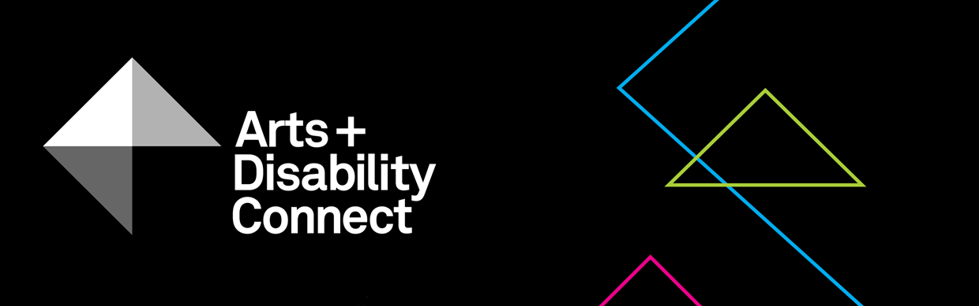

Arts and Disability Connect New Work
Application Form 2019
Read the following before submitting your application:
About the Arts and Disability Connect scheme and New Work Guidelines.

- Please complete this form using Arial 14pt
- All questions must be answered

Section One
- Artist Details:
Name:
Address:
Tel:
Email:
Website:
Artform:
Support Details:
Support email:
(Artists who are being supported to complete their application can include the email address of the person who is supporting them.
This support person will be copied into email correspondence.)
Access requirements:
Include details of your access requirements as they relate to this proposal (max 200 words).

- Declaration:
The Arts Council and ADI take their definition of disability from the UN Convention on the Rights of Persons with Disabilities which states:
‘Persons with disabilities include those who have long-term physical, mental, intellectual or sensory impairments which, in interaction with various barriers, may hinder their full and effective participation in society on an equal basis with others.’
Using this definition, would you define yourself as being a person with a disability? You must tick one box, either Yes or No.
Yes
No

- Arts partner details:
Name:
Organisation:
Address:
Tel:
Email:
Website:
Is the arts partner in receipt of Arts Council funding?
You must tick one box, either Yes or No.

Yes
No

Section Two
- Arts and Disability Connect New Work Proposal:
- Amount requested: €___________
Make sure this matches the figure in your budget and that it does not exceed €8,000.
- The proposal:
Ensure that you have read the criteria on pages 3-5 of the New Work Guidelines document before completing this section (max 800 words).

- The timeframe:
Indicate the start date, all key dates and an end date (max 200 words).
- How will this award benefit your practice?
(max 150 words)

- How will the connection with your arts partner/s benefit your practice?(max 150 words)

- How will this award assist you to reach new and diverse audiences? (max 200 words)

- How will your work be documented? (max 200 words)

- The Team:
Please list all artists, individuals, groups or organisations involved in your proposal.
First name | Surname | Organisation | Involvement in project
2 Budget
This template budget breaks down your costs across artistic costs, administrative costs, production and presentation costs and includes additional section for arts partner/s costs if relevant.
Please ensure:
- all costs are included
- the budget is balanced
i.e. that total income matches total expenses
- the amount requested is not higher than the maximum offered
- any relevant income is included and clearly marked ‘in-kind’ or ‘in cash’.
Item | Amount | Notes
1. Artistic costs | €
Artist(s) Fees
Materials
Access
Travel/Subsistence
Other expenses
Sub-total 1:
2. Administrative costs
Office costs
Postage and stationery
Publicity and PR
Insurance
Documentation
Other
Sub-total 2:
3. Production/ presentation of work
Venue hire
Technical equipment/transport
Audience access costs
Other
Sub-total 3:
4. Other arts partner costs if relevant
Please provide detail
Sub-total 4:
Total expenses (=1+2+3+4)
5. Amount applied for from ADC New Work
6. Other sources of income (please list) |  | Indicate if in-kind/cash and if confirmed/unconfirmed
Total income (=5+6)

3 Signatures:
I have read the award guidelines and conditions and agree to be bound by them. I certify that this application is led by the applicant named below and that the information in this application is correct to the best of my knowledge.
Signed: (Applicant)
Signed: (Arts partner)
Both signatures are required. Remember this page must be scanned or photographed and submitted as a .pdf or .jpg as per the guidelines.

- Final Checklist:
Please check you have answered all of the questions on the Arts and Disability Connect New Work application form using Arial font, size 14pt. Please ensure that you have saved your completed application form as a .doc file.

Please check you have uploaded all of the required supporting material along with your completed application form:
- A .pdf or .jpg of the signed signature page

- Your CV and CVs of other key artists and arts partner/s
(each CV should be a maximum of 3-4 pages)
- A letter of commitment from the main arts partner

- Examples of previous work (max 10 images or 3 texts/ video work/ audio clips (5 min max) of up to 1gb in the following formats: .jpg; .wav; .mp3; .mp4; .pdf; .doc) and examples of any relevant press/ media coverage (2 pages maximum)

- List of supporting material provided in a word file (.doc)

- The upload limit for one WeTransfer is 2gb in total. Only one We Transfer can be submitted by each applicant, this must include a completed application form and all support materials.

- Please note: applicants may submit an application for only one strand of ADC i.e. you must choose to apply either for Arts and Disability Connect New Work or Arts and Disability Connect Mentoring or Arts and Disability Connect Training.

You must submit your completed application form along with all supporting material to amie@adiarts.ie using WeTransfer
by 4pm on Monday 8 April, 2019.
- Feedback
Thank you for applying to Arts and Disability Connect New Work.
The Arts Council and ADI would appreciate it if you could provide feedback on this scheme. Your comments will help to shape the scheme in the future.
We will send you a link to a survey on receipt of your application.

