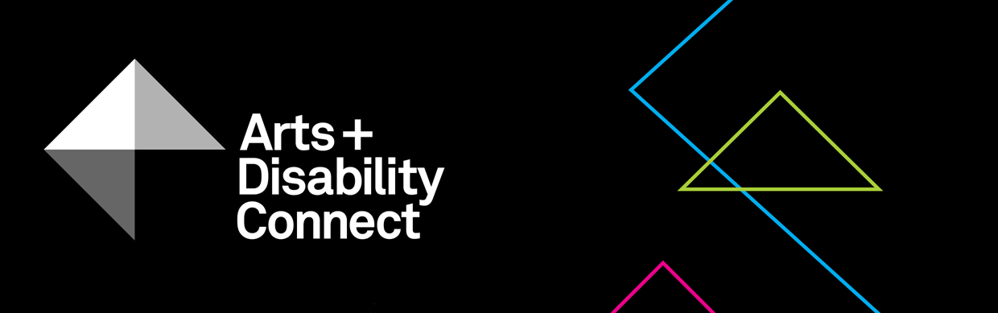

Arts and Disability Connect Mentoring Guidelines 2020
About the Arts and Disability Connect scheme
ADC is a funding scheme available to artists with disabilities.
There are three different strands within ADC, each with specific aims, objectives and criteria against which applications will be assessed. The three strands are: Arts and Disability Connect New Work, Arts and Disability Connect Mentoring and Arts and Disability Connect Training.
This scheme is funded by the Arts Council/An Chomhairle Ealaíon and managed by Arts & Disability Ireland (ADI).
Please read the following before submitting your application: About the Arts and Disability Connect scheme, Application Forms and Guidelines. These will be available to download from Monday 13 January 2020 at: www.adiarts.ie/connect
Deadline for all ADC applications: 4pm, Monday 24 February 2020.

Arts and Disability Connect Mentoring Guidelines

- Aims and objectives
Arts and Disability Connect Mentoring aims to support individual artists with disabilities across all artforms and at all stages in their career to consider, develop and extend their practice through a process of mentoring with an experienced artist or other arts professional for a defined period of up to six months. The mentor should be an arts professional with a strong track record of making, producing or presenting work in recognised arts contexts.

Further information about mentoring is available in the accompanying document “What is mentoring?”.

It is understood that the nature and structure of the mentoring relationship will differ from one artist to the next. More established mentees may require opportunities for mutual sharing and exploration of practice while those at an earlier stage of their career may require higher levels of support and guidance. However, in all cases, it is envisaged the award will support artists to:
- critically reflect, discuss, and experiment with aspects of their practice
- explore alternative approaches to making and presenting work
- share information, advice, resources and contacts

- Timeframe
The mentoring process should take place at any stage between May 2020 and April 2021. The mentoring may take place intensively over a short period of time or may be stretched out over a maximum period of six months.
- Purpose
The funding may be used to pay for the mentee’s expenses related to relevant materials, access and travel within the Republic of Ireland as well as the mentor’s fees, inbound travel costs and expenses. It is expected that a minimum of six meetings is agreed between mentor and mentee and that at least three of these are face to face.
- Restrictions
While the award allows for the purchase of materials during the course of the mentoring process, it is not designed to be a capital grant and may not be used to cover the purchase of significant items of equipment.
Funding is not available for mentoring that has already taken place or that will have commenced before May 2020.
The mentor in your application may only support one mentoring application in the ADC scheme for 2020.
Successful applicants cannot commence the mentoring process until the Arts and Disability Connect scheme conditions have been signed and returned to ADI.
- Maximum amount available
The maximum amount available is €2,000; up to €1,000 for the fees and expenses of the mentee and up to €1,000 for the fees and expenses of the mentor.
- Supported applications
The Arts and Disability Connect scheme understands that some artists require additional supports to submit an application. Where this is necessary we welcome applications that are compiled by staff in supported studios, support workers, family or friends on behalf of an artist with a disability. In the application it is possible to have two voices, that of the applicant artist and the person who is supporting them to apply. However the priority for the decision making panel is to hear the voice and views of the individual artist who is applying.

- Criteria
All applications must be led by an artist with a disability.
As with all Arts Council awards, the ADC applications will be assessed against criteria of (i) artistic merit; (ii) how they meet the objectives of the award and (iii) feasibility.
- Artistic merit
You must demonstrate:
- evidence of your emerging or established arts practice
- an understanding of your practice development needs
- an imaginative and ambitious approach towards working with a mentor
- that the proposed mentor is skilled and experienced within their own professional contemporary arts practice

- Meeting the objectives of the award
You must describe:
- the ways in which the engagement with your chosen mentor will help you to develop and extend specific elements of your practice

- Feasibility
You must include:
- a clear and considered plan showing where and how you and the mentor will work together
- a proposed timetable for your meetings
- information about your access requirements during the mentoring process and how they will be met
- information about the access requirements of the mentor (if applicable) and how they will be met
- a clear breakdown of the proposed expenditure and any additional income that may be relevant to the proposal
- a letter of commitment from the mentor
- Other conditions applying to all Arts Council awards:
All awards are offered subject to the availability of funds. Awards may be withheld or divided among applicants at the discretion of the Arts Council.
Successful applicants must acknowledge the support of the Arts Council and ADI in all promotional material associated with their work.
All correspondence should be with the applicant directly, unless otherwise agreed.
Successful applicants must report on the use of the award and supply receipts where appropriate.
- Supporting materials relating to mentoring
A document with further information on mentoring, “What is mentoring?” can be found at: www.adiarts.ie/connect

- How to apply
Using one WeTransfer, you must submit:
- A completed application form
- A signed signature page
- Your CV and CV of the mentor (max 3-4 pages each)
- A letter of commitment from the mentor
- Examples of previous work - max 10 images, 3 texts, 3 video work or 3 audio clips (max 5 mins each) and examples of any relevant press or media coverage (max 2 pages)
- List of supporting material submitted
File types that you can submit as part of your application:
Text files - .doc or.docx
Image files - .jpg
Sound files - .mp3
Video files - .mp4
Adobe Acrobat Reader files - .pdf
The upload limit for one WeTransfer is 2gb in total. Only one WeTransfer can be submitted by each applicant, this must include a completed application form and all support materials. Please note: applicants may submit an application for only one strand of ADC.
Please bear in mind the competitive context of the award when submitting support material. Select materials carefully and ask yourself if they make a persuasive case for your specific proposal.
- How to use WeTransfer
- Go to www.wetransfer.com
- Add your files: select all of the files you want to submit
- Email to: amie@adiarts.ie
- Your email: (insert your own email address)
- Message: Arts and Disability Connect Mentoring application - (insert your name)
- Click Transfer
- You will receive a confirmation email from WeTransfer stating that the files have been sent and a confirmation email when the files are downloaded by ADI

Including architecture, circus, dance, film, literature, music, opera, street arts and spectacle, theatre, traditional arts and visual arts.

