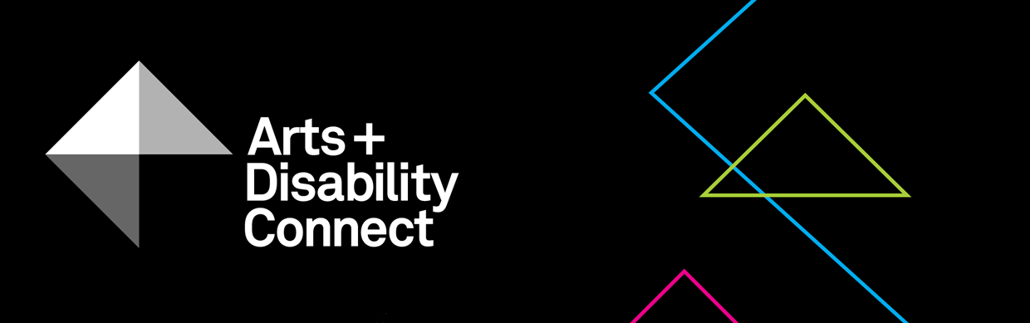

Arts and Disability Connect Mentoring
Application Form 2020
Read the following before submitting your application:
About the Arts and Disability Connect scheme and Mentoring Guidelines.

Applicant’s name: (insert name here)

- Please complete this form using Arial 14pt
- All questions must be answered

Section One
- Artist Details:
Name:
Address:
Tel:
Email:
Website:
Artform:
Please select from the following Arts Council supported artforms -architecture, circus, dance, film, literature, music, opera, street arts and spectacle, theatre, traditional arts and visual arts.
Support Details:
Support email:
(Artists who are being supported to complete their application can include the email address of the person who is supporting them.
This support person will be copied into all email correspondence.)
Access requirements:
Include details of your access requirements as they relate to this proposal (max 200 words).

- Declaration:
The Arts Council and ADI take their definition of disability from the UN Convention on the Rights of Persons with Disabilities which states:
‘Persons with disabilities include those who have long-term physical, mental, intellectual or sensory impairments which, in interaction with various barriers, may hinder their full and effective participation in society on an equal basis with others.’
Using this definition, would you define yourself as being a person with a disability? You must tick one box, either Yes or No.
Yes
No
- Mentor details:
Name:
Address:
Tel:
Email:
Website:
Artform:
Access requirements if applicable (max 200 words):

Mentor Statement
Please outline why you want to mentor the applicant artist and what approach you might take (max 200 words):

Have you worked with this mentor before?
You must tick one box, either Yes or No.

Yes
No

Section Two

- Arts and Disability Connect Mentoring Proposal:
- Amount requested: €___________
Make sure this matches the figure in your budget and that it does not exceed €2,000.
- The mentoring plan:
Ensure that you have read the criteria on page 4 of the Mentoring Guidelines document before completing this section (max 400 words):

- Timeframe and schedule of meetings:
Indicate the start date, all meeting dates and an end date between May 2020 and April 2021. (max 200 words):

- How will this mentoring process benefit your practice?
(max 200 words)

- How will you document the mentoring process and its outcomes? (max 200 words)

- Budget
Income is funding and expenditure are costs related to your proposal. This is a template to use as a starting point. Remove, add or edit descriptions to fit your proposal.
Please ensure:
- all costs are included
- the total income matches the total expenditure
- the amount requested is not higher than the maximum offered
Income and Expenditure budget template
Description | € Amount | Notes
Income
Arts and Disability Connect Mentoring award | € | This amount must match the amount requested on page 5
Other (if relevant) | € | Indicate if in-kind or in cash and if confirmed or unconfirmed
Total Income | €
Expenditure
Applicant expenditure
Applicant’s fee | €
Materials | €
Access | €
Travel | €
Expenses | €
Documentation | €
Mentor expenditure
Mentor’s fee | €
Access | €
Travel | €
Expenses | €
Total Expenditure | € | Total income must match total expenditure

- Signatures:
I have read the award guidelines and conditions and agree to be bound by them. I certify that:
- the application is led by the applicant
- the proposal has been developed and agreed with the named mentor
- the information in this application is correct to the best of my knowledge
Signed: (Applicant)
Signed: (Mentor)

Both signatures are required. Remember this page must be scanned or photographed and submitted as a .pdf or .jpg as per the guidelines.

5 Final Checklist:
Please check you have answered all of the questions on the Arts and Disability Connect Mentoring application form using Arial font, size 14pt. Please ensure that you have saved your completed application form as a .doc, .docx or .pdf file.
Please check you have uploaded the following:
- A completed application form
- A signed signature page
- Your CV and CV of the mentor (max 3-4 pages each)
- A letter of commitment from the mentor
- Examples of previous work - max 10 images, 3 texts, 3 video work or 3 audio clips (max 5 mins each) and examples of any relevant press or media coverage (max 2 pages)
- List of supporting material submitted
File types that you can submit as part of your application
Text files - .doc or.docx
Image files - .jpg
Sound files - .mp3
Video files - .mp4
Adobe Acrobat Reader files - .pdf
The upload limit for one WeTransfer is 2gb in total. Only one WeTransfer can be submitted by each applicant, this must include a completed application form and all supporting materials.
Please note: applicants may submit an application for only one strand of ADC i.e. you must choose to apply either for Arts and Disability Connect New Work or Arts and Disability Connect Mentoring or Arts and Disability Connect Training.
You must submit your completed application form along with all supporting material to amie@adiarts.ie using one WeTransfer
by 4pm on Monday 24 February 2020.
Feedback
Thank you for applying to Arts and Disability Connect Mentoring.
The Arts Council and ADI would appreciate it if you could provide feedback on this scheme. Your comments will help to shape the scheme in the future. We will send you a link to a survey on receipt of your application.

