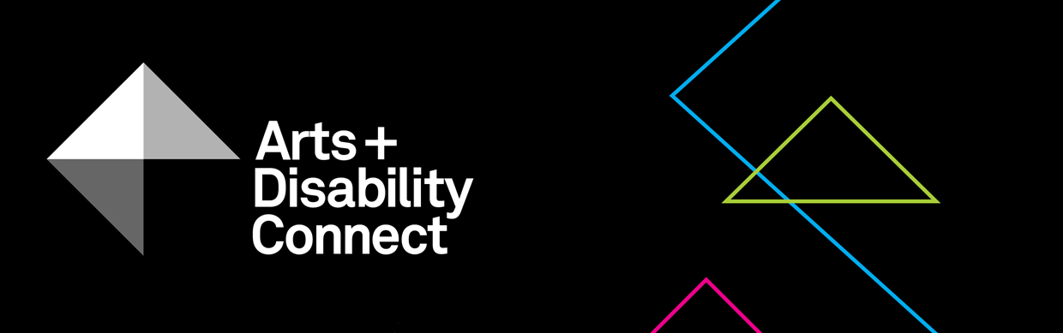

Are groups of people with disabilities eligible to apply to Arts and Disability Connect?
No, groups cannot make an application through the Arts and Disability Connect scheme. These awards are for individual artists with disabilities only. For funding opportunities available for groups of people with disabilities see the Arts Council’s Artist in the Community Scheme or Arts Participation Project Awards.
If I make an application what chance have I of being awarded funding?
The amount of applications we receive and the amount of awards offered change from year to year. The Arts Council have increased the funding available to artists with disabilities by €10,000 in 2020.
2014 20 applications, 7 awards 35%
2015 26 applications, 9 awards 35%
2016 17 applications, 7 awards 42%
2017 24 applications, 11 awards 46%
2018 26 applications, 13 awards 50%
2019 38 applications, 14 awards 37%
Who has been funded by Arts and Disability Connect?
61 awards have been made to artists with disabilities through the Arts and Disability Connect since it began in 2014. All of the successful artists are listed on our website here: www.adiarts.ie/connect
You can click on each of the artists names to read project descriptions of their awards.
Can you give examples of arts partners from previous New Work awards?
Dance Ireland were the arts partner for Áine Stapleton’s award. Dance Ireland supported Áine by giving her financial support and studio space to host a work in progress presentation of her New Work Horrible Creature.
Town Hall Theatre were the arts partner for Mairéad Folan’s award. Town Hall Theatre supported Mairéad by giving her financial support, programming Wake in the Town Hall Theatre Studio, giving in kind technical support and marketing support.
Leitrim Sculpture Centre were one of the arts partners for Ruth Le Gear’s award. LSC supported Ruth by programming her exhibition Water Senses and launching her accompanying publication. The Model were the other arts partner and supported Ruth by stocking her Water Senses publication and providing critical feedback while she developed the work.
How do I approach potential mentors/trainers/arts partners?
An email or phone call is a good place to start! Tell them what funding award you are applying for and explain why you would like to work with them. They will let you know if they can be involved in your proposal and if they can’t they may be able to suggest someone else for you to get in touch with.
If I don’t know any mentors/trainers/arts partners can you make suggestions?
Yes, if you have an idea of what you would like to do, contact us and we can suggest people for you to approach.
What are access requirements?
Access requirements are things that take away any barriers that might stop you from completing your Training, Mentoring or New Work proposal.
A Mentoring applicant may need their mentor to travel to their home studio for their face to face mentoring meetings. This could be an access requirement for an artist who experiences chronic fatigue.
A New Work applicant may need the venue where their work is being presented, rehearsal spaces and meeting spaces to be wheelchair accessible spaces. This would be an access requirement for an artist who has a physical impairment.
A New Work applicant may ask the team they were working with and their arts partners to respond to emails within one working day. This could be an access requirement for an artist who experiences anxiety.
A Training applicant may need to work one on one with one person and tailor make a consistent training programme over a long period of time. This could be an access requirement for an artist who has an intellectual disability.
If you don’t have any access requirements in order to complete your proposal you can put N/A or Not Applicable in the box instead.
Can I get feedback on draft applications?
Yes you can book in applicant support up until the 21 February. This is for up to one hour of support either on the phone/Skype or by email. During this applicant support we can review a draft application and make suggestions.

2021 – social welfare
Example of an artistic CV
Example of completed budget

