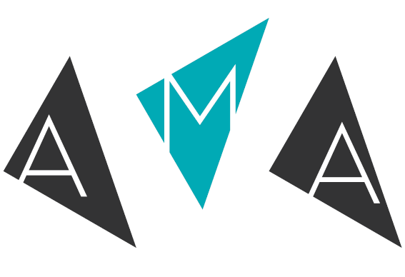

AMA conference 2017 | 25 – 27 July 2017 | Belfast Waterfront
Stagetext Bursary
— for people who are deaf, deafened or hard of hearing
Application Form
Stagetext will provide one AMA conference 2017 bursary for professionals working within the arts, culture and heritage sector who are deaf, deafened or hard of hearing and benefits from live subtitling access. If your application is successful, you’ll only need to contribute £100 + VAT towards your place (you’ll need to fund your own travel and accommodation).

This year, Stagetext is sponsoring a deaf, deafened or hard of hearing professional who will benefit from live subtitling access to attend the AMA conference 2017. The breakout sessions which the successful applicant chooses to attend will be live subtitled to ensure equal access alongside their hearing peers. The keynote sessions will also be live subtitled.

Criteria:

- You are deaf, deafened or hard of hearing and would benefit from live subtitling access.
- You are a member of the AMA network. If you are not currently an AMA member and your bursary application is successful, we will ask you to join. You must be a member at the time of attending the conference. Membership starts from 60 + VAT. For more information, visit www.a-m-a.co.uk/joinus.

Please note:

- Bursaries won’t be awarded to more than one person from the same organisation.
- If you’ve already booked your conference place and your application is successful, the AMA will refund you the difference.

How to apply:

Complete this application form and return it to Laurie by Tuesday 9 May 2017.
- Email: laurie@a-m-a.co.uk
- Fax: 01223 245862
- Post: AMA, 7a Clifton Court, Clifton Road, Cambridge CB1 7BN
Next steps:

- The AMA and Stagetext will review each application and will email all applicants with a final decision by mid/end May 2017.
- If you are successful we’ll be asking you to share your AMA conference learning and experience (this could be in the form of a blog post, a CultureHive case study, etc.).

- Your contact details

Full Name:

Job Title:

Organisation:

Address:

Email:

Phone:

Are you an AMA member?

Yes
No

- How long have you worked in arts marketing / audience development?

Up to 6 months
6 - 12 months
1 - 2 years
2 - 3 years

- Number of dedicated marketing / audience development staff in your organisation:

No dedicated person
One
Two
Three
Four or more

- Indicate your organisation’s annual turnover for the last full financial year:
Less than £49,999 |  | £1m –£1.5m
£50,000 – £99,000 |  | £2.5m – £5m
£100,000 – £249,999 |  | £5m – £10m
£250,000 – £499,999 |  | £10m – £15m
£500,000 – £999,999 |  | Over £15m

- Why are you interested in attending AMA conference 2017 (up to 200 words)?

- Please state your reasons for applying for this bursary (up to 200 words):

- Statement of support — to be completed by line manager or senior colleague.
How will the applicant and the organisation benefit from attending AMA conference 2017 (up to 200 words)?

Full Name:
Job Title:

Organisation:

Relation to applicant:

Arts Marketing Association, 7A Clifton Court, Cambridge, CB1 7BN, UK
+44 (0)1223 578078
AMA registered in England, 2814725

