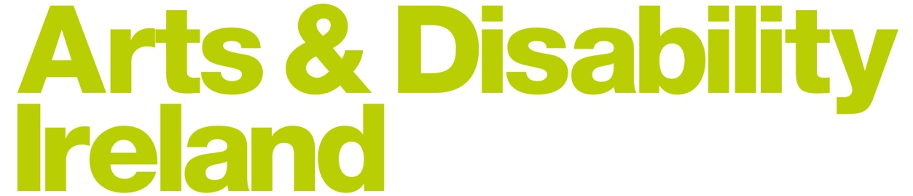

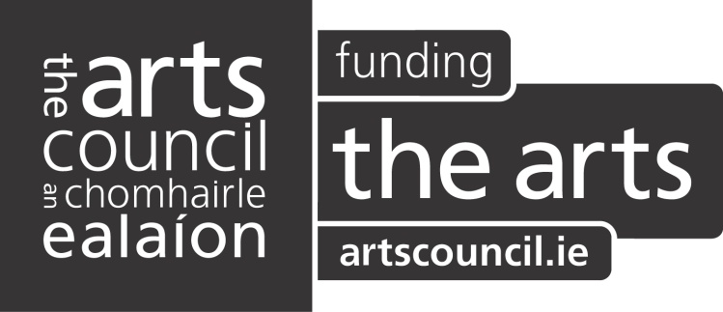



An easy-to-read guide to

**The Going Out Survey**

From

Arts and Disability Ireland

A guide to the survey questions

April 2017

**What is this document about?**

This is an easy-to-read guide to a survey from Arts and Disability Ireland.

Arts and Disability Ireland have joined with other organisations so they can get information that will help people with disabilities.

The survey would like to find out what would make it easier for people to go out and enjoy themselves.

It will ask you questions around

* How often do you go out
* What do you like doing in your spare time
* What stops you from going out

This guide is a much smaller document than the survey itself.

You may need some support from someone to fill the survey out.

The survey should only take a few minutes of your time.

The survey has 23 questions.



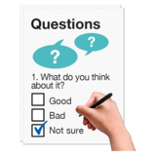





**What do you do in your spare time? - Questions 1 – 6**

These questions are asking you what activities you do in your free time

These activities could be:

* Going to the cinema
* Going to the pub
* Going to a sports event

These questions also want to know:

* How often do you do these activities
* If you go out to the community to do them

This part also wants to know if you have gone to any plays or events in the past year.

These could be:

* Theatre or plays
* Dancing
* Music
* Sport

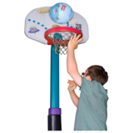

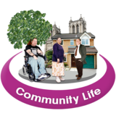

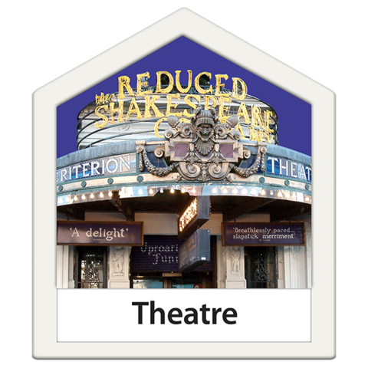

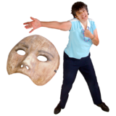

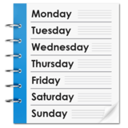







**What do you think about going out? - Questions 7 and 8**

This section wants to know what you think a good day or night out is.

Also, what days or nights of the week do you like to go out on?

**How have things changed? Question 9**

This part wants to know what activities you used to do 5 years ago.

These could be:

* Going to the library
* Going to a nightclub
* Going to a gig

**How would you like things to change? Questions 10 and 11**

This part wants to know if there are any activities you would like to do more often.

Does anything stop you from doing these activities?

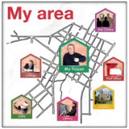





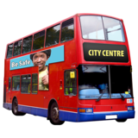



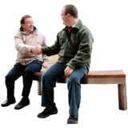

**Finding out what’s happening – Questions 12 and 13**

This section wants to find out where in your area you could go to see an event.

Also, how do you find out about these local events in your community?

This could be from:

* Radio
* TV
* Internet

**Thinking about your last visit – Questions 14, 15, 16 and 17**

These questions want to know

* How often do you go to live events
* Do you have to travel far
* Who do you go with
* Do you go by yourself

Also, why did you go to these events?

Such as:

* To spend time with people
* To do something different

**Tell us about yourself – Questions 18, 19 and 20**

This part of the survey is to find out if there are certain groups who have access needs that are not being met.

It asks:

* If you are male or female
* What age you are
* Where you live and who you live with

**About yourself – Questions 21, 22 and 23**

This section is to find out how many people find it difficult to get out and do things because:

* They have a disability

or

* They have a long-lasting health problem

This section will mean that we will get the opinions of people who do not find it easy to get out.



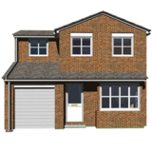

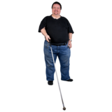

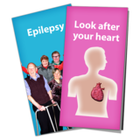

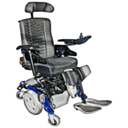

This Easy-to-Read Document was developed by Inclusion Ireland for Arts and Disability Ireland.

The document was proof-read by men and women with disability.





“© European Easy-to-Read Logo: Inclusion Europe. More information at [www.easy-to-read.eu”.](http://www.inclusion-europe.org/etr%E2%80%9D.)