Raphaëlle de Groot, Study 5, A New Place - Head Remnants, 2015.
Head shape scans (diptych) mixed media.
Two photos placed next to each other. Different angles of a primitive sculpture of a head, made up of found rubbish. The left photograph is a side profile. To the right is the back of the head.
We'll begin with the side profile. The head is placed with the face turned to the left. The face appears to be made from thin weather worn leather, or perhaps thick paper, shades of brown with splashes of grey blue. A nose is evident with one large cavernous nostril. There is a water stain where an eye might be and the material has been folded at the top to look like a forehead.
Crumpled brown paper bags are scrunched and moulded behind this mask to shape the rest of the head. White crumpled paper with a swirl of white cotton behind and above the forehead. Remnants of a white mesh fruit bag poke out from within the crumpled paper and fall down the side in amongst scraps of frayed coloured ribbon – baby pink, violet and orange knotted together. A messy spiral of blue cotton tied in amongst it all.
Light shines on the head from the right casting shadows across the textured sculpture making the facial features more prominent.
The right hand photograph gives us a view of the back of the head. Offering a glimpse of the inside mechanisms. Largely made up of scrunched, crumpled and textured weather worn brown paper bags, sun faded in parts.
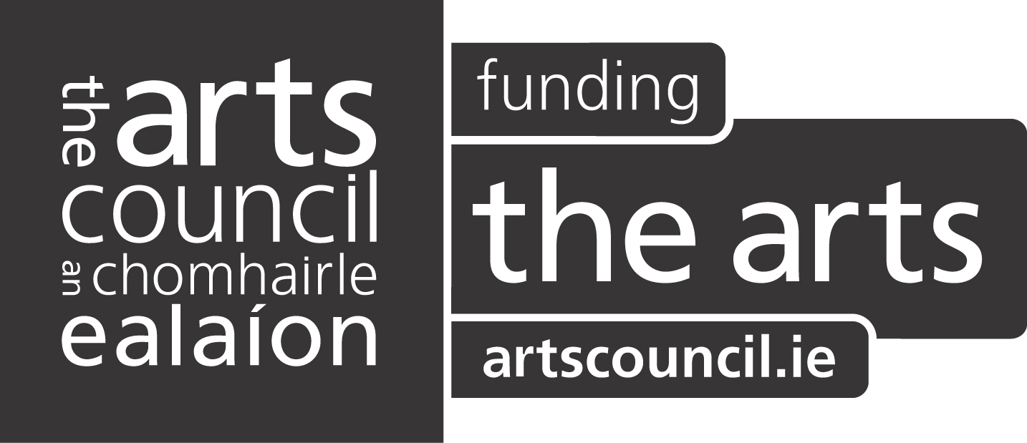

White rope knotted in places peeps out from inside the head. Sweet wrappers, blue and silver placed near the top to the right. Grimy thin, light blue string pokes out from the left, hanging down. A swirl of blue cotton peeps out just below the sweet wrapper.
To the right of the head a small fold of white paper, a glimpse of red paper, frayed white rope and dirty knotted material hang.
Sunlight hits the textured sculpture.

