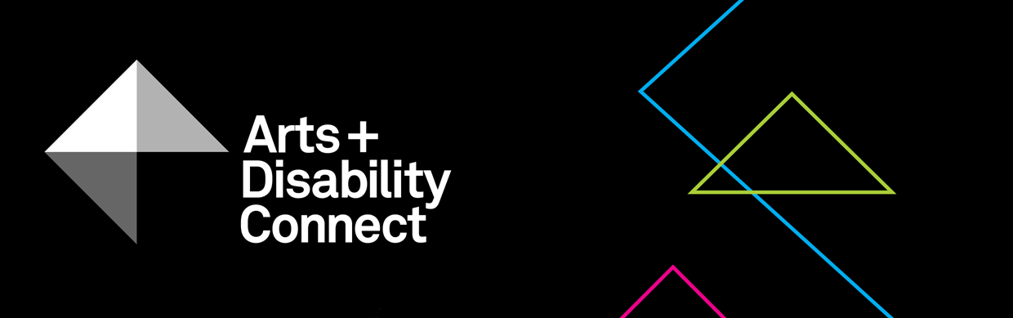

Arts and Disability Connect Training
Guidelines 2018

About the Arts and Disability Connect scheme
ADC is a funding scheme available to individual artists with disabilities.
There are three different strands within ADC, each with specific aims, objectives and criteria against which applications will be assessed. The three strands are: Arts and Disability Connect New Work, Arts and Disability Connect Mentoring and Arts and Disability Connect Training.
This scheme is funded by the Arts Council/An Chomhairle Ealaíon and managed by Arts & Disability Ireland (ADI).
Please read the following before submitting your application: About the Arts and Disability Connect scheme, Application Forms and Guidelines. These will be available to download from Monday 5 March 2018 at: www.adiarts.ie/connect
Deadline for all ADC applications: 5pm, Thursday 26 April, 2018.

Arts and Disability Connect Training Guidelines

- Aims and objectives
Arts and Disability Connect Training aims to support artists across all artforms and at all stages of career development, including emerging artists, to engage in training courses, events and other professional development opportunities delivered by established artists and professional arts organisations in Ireland. The proposed training may be limited to a concentrated period of time such as a weekend or a week, or it may include attendance at a number of events spread out over a maximum of twelve months. Artists wishing to avail of professional development opportunities outside the island of Ireland should not apply to this award, and are directed to the Arts Council's Travel and Training award.
In this way, Arts and Disability Connect Training aims to add value to other existing supports for professional development and assist artists to:
- learn new skills and extend current practice through participation in:
  - training days, short courses, masterclasses in the applicant’s own artform
  - other professional development opportunities such as residencies etc.
- develop new strategic contacts with other artists and arts organisations within the island of Ireland

All applicants must contact Arts & Disability Ireland in advance of the application deadline in order to discuss their chosen training provider
OR get advice on appropriate training providers.

- Timeframe
All proposed training, events or programmes must be completed before the end of June 2019.

- Purpose
The funding can be used to pay for the applicant’s expenses related to the course or event fees, materials, access and travel within the island of Ireland.

- Restrictions
Funding is not available for formal education courses at primary, secondary or tertiary level, vocational education and recreational classes.
While the award allows for the purchase of materials for use during the training period, it is not designed to be a capital grant and may not be used to cover the purchase of significant items of equipment.
Funding is not available for training that has already taken place or that will have commenced before June 2018.

- Maximum amount available
The maximum amount available is €1,000.

- Criteria
All applications must be led by an individual artist with a disability.
As with all Arts Council awards, the ADC applications will be assessed against criteria of (i) artistic merit; (ii) how they meet the objectives of the award and (iii) feasibility.
- Artistic merit
You must demonstrate:
- a strong track record in emerging or established arts practice
- evidence of a professional arts practice
- evidence that the artists/ producers/ arts organisations delivering the training are skilled and experienced within their own professional arts practice

- Meeting the objectives of the award
You must describe:
- your professional development needs and the ways in which the proposed training will address these needs

- Feasibility
You must include:
- detailed information about the content of the proposed training/ events and the artists responsible for delivery of training
- a timetable for the proposed training/ event/s
- evidence that you have secured a place on the course
- information about your access requirements during the proposed training and how they will be met
- a clear breakdown of the proposed expenditure
(and any other income that might be relevant to the proposal)

- Other conditions applying to all Arts Council awards:
All awards are offered subject to the availability of funds. Awards may be withheld or divided among applicants at the discretion of the Arts Council.
Successful applicants must acknowledge the support of the Arts Council and ADI in all promotional material associated with their work.
All correspondence should be with the applicant directly, unless otherwise agreed.
Successful applicants must report on the use of the award and supply receipts where appropriate.
- How to apply
Using one WeTransfer, you must submit:
- A completed Arts and Disability Connect Training application form (.doc) filled out in Arial 14pt
- Your CV (3-4 pages max)
- Confirmation of a place on the course
- Supporting document(s) with examples of:
  - previous work (max 10 images or 3 texts/ video work/ audio clips (5 mins max) of up to 1gb in the following formats: .jpg; .wav; .mp3; .mp4; .pdf; .doc)
  - selected press/ media coverage if available (2 pages max)
  - information/ brochures about the proposed training, the organisation offering it and the artist/s delivering the training
- A list of all of your supporting documentation
- The upload limit for one WeTransfer is 2gb in total. Only one We Transfer can be submitted by each applicant, this must include a completed application form and all support materials.
- Please note: applicants may submit an application for only one strand of ADC.
Please bear in mind the competitive context of the award when submitting support material. Select materials carefully and ask yourself if they make a persuasive case for your specific proposal.
- How to use WeTransfer

- Go to www.wetransfer.com
- Select ‘Take me to Free’
- Read the Terms of Service and click ‘I agree’
- Add the files you wish to send
- Enter recipient email address: amie@adiarts.ie
- Enter your own email address
- Add a message e.g. Arts and Disability Connect Training application - (insert your name)
- Click Transfer
- You will receive a confirmation email from WeTransfer stating that the files have been sent and a subsequent confirmation email when the files are downloaded by ADI.

Including architecture, circus, dance, film, literature, music, opera, street arts and spectacle, theatre, traditional arts and visual arts.
Professional arts organisations might include artform resource organisations, festivals, production companies, venues, studios, etc.

