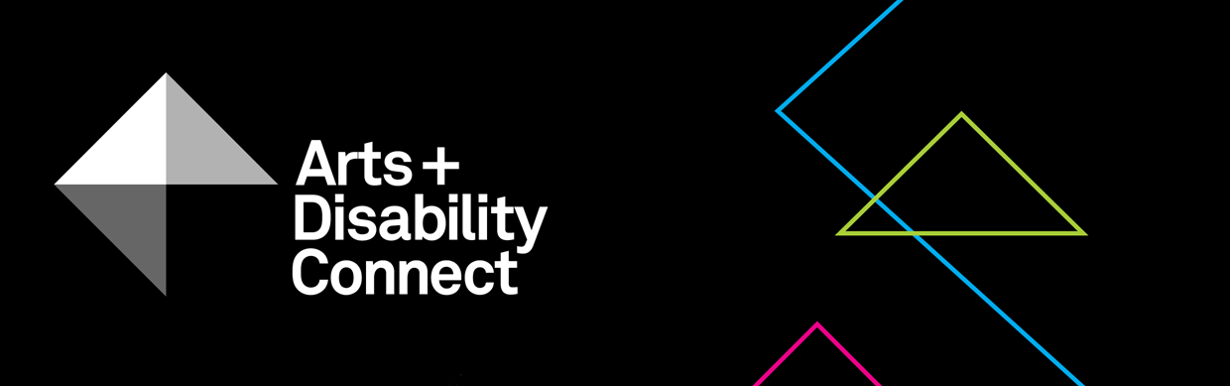

Arts and Disability Connect New Work Guidelines 2018

About the Arts and Disability Connect scheme
ADC is a funding scheme available to individual artists with disabilities.
There are three different strands within ADC, each with specific aims, objectives and criteria against which applications will be assessed. The three strands are: Arts and Disability Connect New Work, Arts and Disability Connect Mentoring and Arts and Disability Connect Training.
This scheme is funded by the Arts Council/An Chomhairle Ealaíon and managed by Arts & Disability Ireland (ADI).
Please read the following before submitting your application: About the Arts and Disability Connect scheme, Application Forms and Guidelines. These will be available to download from Monday 5 March 2018 at: www.adiarts.ie/connect
Deadline for all ADC applications: 5pm, Thursday 26 April, 2018.

Arts and Disability Connect New Work Guidelines

- Aims and objectives
Arts and Disability Connect New Work aims to support established artists with disabilities working in all artforms to connect with other experienced artists, arts professionals, and arts organisations in the Republic of Ireland. This award is focused on the making and development of ambitious new work and the planning of its production and presentation.
By prioritising ‘connection’, Arts and Disability Connect New Work aims to support professional artists with disabilities to:
- extend their practice and make ambitious new work in collaboration with a strategic arts partner
- build relationships with key people or organisations experienced in high quality production and presentation of work
- participate in a public presentation of the finished work or work-in-progress (e.g. staged reading, exhibition, performance etc.)
- reach larger audiences (both with and without disabilities)
- document their work as a means of promoting it more widely

- Timeframe
The funding may be used between June 2018 and July 2019.
- Purpose
Funding may be used to cover the cost of the applicant’s materials, access and travel within the Republic of Ireland as well as some costs incurred by the named arts partner/s. As the award is designed to support individual artists with disabilities, a maximum of 25% of the total budget may be allocated to costs incurred by the arts partner/s.
- Restrictions
While the award allows for the purchase of some materials for the purpose of making work, it is not designed to be a capital grant and may not be used to cover the purchase of significant items of equipment. Applications for capital purchases will not be considered eligible.
Funding is not available for work that has already taken place or that will have commenced before June 2018.
- Maximum amount available
The maximum amount available is €8,000, of which up to 25% of the total budget may be allocated to costs incurred by the arts partner/s. If the arts partner wishes to give its support in kind the full budget can be allocated to the applicant.
It should be noted that the full amount will only be awarded where proposals demonstrate exceptional scope and ambition. Artists are welcome to submit proposals for smaller amounts.
- Criteria
All applications must be led by an individual artist with a disability.
All applications must involve at least one arts partner.
As with all Arts Council awards, the ADC applications will be assessed against criteria of (i) artistic merit; (ii) how they meet the objectives of the award and (iii) feasibility.

- Artistic merit
You must demonstrate:
- a strong track record in your established professional practice through your CV and supporting documentation
- an imaginative, ambitious and relevant proposal for developing work with the named arts partner/s
- a strong professional arts practice from the named arts partner/s

- Meeting the objectives of the award
You must describe:
- the ways in which your practice will benefit or be developed as a result of the proposed activity
- the ways in which you will be able to reach new audiences through the proposed collaboration
- the ways in which the work will be documented

- Feasibility
You must include:
- a clear and considered plan outlining how you and the named arts partner/s will work together in the making, production and presentation of work
- a proposed timetable or schedule for this work
- information about the supports available from the main arts partner
- information about any additional arts partners and collaborators who will be involved
- information about your access requirements as an artist and how they will be met
- information about the ways in which the access requirements of audiences will be considered
- a clear breakdown of the proposed expenditure and any income that is relevant to the proposal
- a letter of commitment from the main arts partner involved

- Other conditions applying to all Arts Council awards:
All awards are offered subject to the availability of funds. Awards may be withheld or divided among applicants at the discretion of the Arts Council.
Successful applicants must acknowledge the support of the Arts Council and Arts & Disability Ireland in all promotional material associated with their work.
All correspondence should be with the applicant directly, unless otherwise agreed.
Successful applicants must report on the use of the award and supply receipts where appropriate.
- How to apply
Using one WeTransfer, you must submit:
- A completed Arts and Disability Connect New Work application form (.doc) filled out in Arial 14pt
- A .pdf of the signed signature page
- Your CV and the CV(s) of other key artists or personnel.
(3-4pages max)
- A letter of commitment from the main arts partner
- Supporting document(s) with examples of:
  - previous work (max 10 images or 3 texts/ video work/ audio clips (5 mins max) of up to 1gb only in the following formats: .jpg; .wav; .mp3; .mp4; .pdf; .doc)
  - selected press/ media coverage (2 pages maximum)
- A list of all of your supporting documentation (.doc)
- The upload limit for one WeTransfer is 2gb in total.
Only one We Transfer can be submitted by each applicant, this must include a completed application form and all support materials.
- Please note: applicants may submit an application for only one strand of ADC.
Please bear in mind the competitive context of the award when submitting support material. Select materials carefully and ask yourself if they make a persuasive case for your specific proposal.
- How to use WeTransfer

- Go to www.wetransfer.com
- Select ‘Take me to Free’
- Read the Terms of Service and click ‘I agree’
- Add the files you wish to send
- Enter recipient email address: amie@adiarts.ie
- Enter your own email address
- Add a message e.g. Arts and Disability Connect New Work application - (insert your name)
- Click Transfer
- You will receive a confirmation email from WeTransfer stating that the files have been sent and a subsequent confirmation email when the files are downloaded by ADI.

Including architecture, circus, dance, film, literature, music, opera, street arts and spectacle, theatre, traditional arts and visual arts.
The term ‘arts professionals’ is used in this context to describe a wide range of practitioners including professional producers, directors, curators, choreographers etc.
The term ‘arts organisations’ is used in this context to cover a range of professional arts organisations including venues, festivals, production companies, ensembles etc.

